In Bayesian learning, the posterior distribution depends on: (choose ALL that apply)
Question options: Selected The prior distribution Unselected Only the evidence term Selected The likelihood of observed data Selected The model assumptions (e.g., distribution family)
Which of the following statements best describe a Bayesian Network (BN)? Choose ALL that apply. Question options: Selected It represents a joint probability distribution over a set of variables. Selected It encodes conditional dependencies using a graph Unselected It requires all variables to be continuous. Selected Each node is conditionally independent of its non-descendants given its parents.
Selected The policy defines a mapping from states to actions, , such that at a given state an action should be taken.
In Deep RL, neural networks are used to… Question options: Unselected Increase environment randomness Unselected Force deterministic behavior Unselected Replace reward signals Selected Approximate value or policy functions
What is TRUE about k-means and spectral clustering? Choose ALL that apply. Question options: Unselected K-means does not require the number of clusters to be specified in advance Selected K-means clustering is a centroid-based algorithm, while spectral clustering is a graph-based algorithm Selected K-means clustering is generally faster than spectral clustering and can handle large datasets more efficiently Selected K-Means requires initialization of cluster centroids, which can affect convergence results. Unselected Spectral clustering requires labeled data, while k-means can be applied to dataset without pre-defined labels Selected Spectral clustering uses the eigenvectors of the Laplacian matrix to determine the number of clusters Unselected If we run k-mean clustering algorithm on the same dataset a few times, we will obtain the same clustering results
K-means can be categorised as hard clustering method. Question options: Selected True Unselected False
What are the advantages of spectral clustering? Choose ALL that are TRUE Question options: Selected It is able to find clusters of different sizes Selected It can handle non-linear clusters Unselected It is always able to find the optimal number of clusters
What is a Gaussian Mixture Model (GMM)? Question options: Unselected A type of neural network that is used to classify data points, based on their Gaussian distribution Selected Probabilistic model that assumes that the data can be divided into a number of clusters, each of which is generated by a separate Gaussian distribution. Unselected It is a type of linear regression model, that considers a Gaussian origin of the input data Unselected A statistical model that is used to fit a set of data points with a Gaussian distribution
In a Gaussian Mixture Model (GMM), the Expectation-Maximization (EM) algorithm alternates between: Question options: Unselected Minimizing reconstruction error using backpropagation. Unselected Sampling new latent variables via Monte Carlo methods. Unselected Assigning data to the nearest centroid and recomputing means. Selected Estimating the hidden variable posteriors and re-estimating parameters to maximize likelihood.
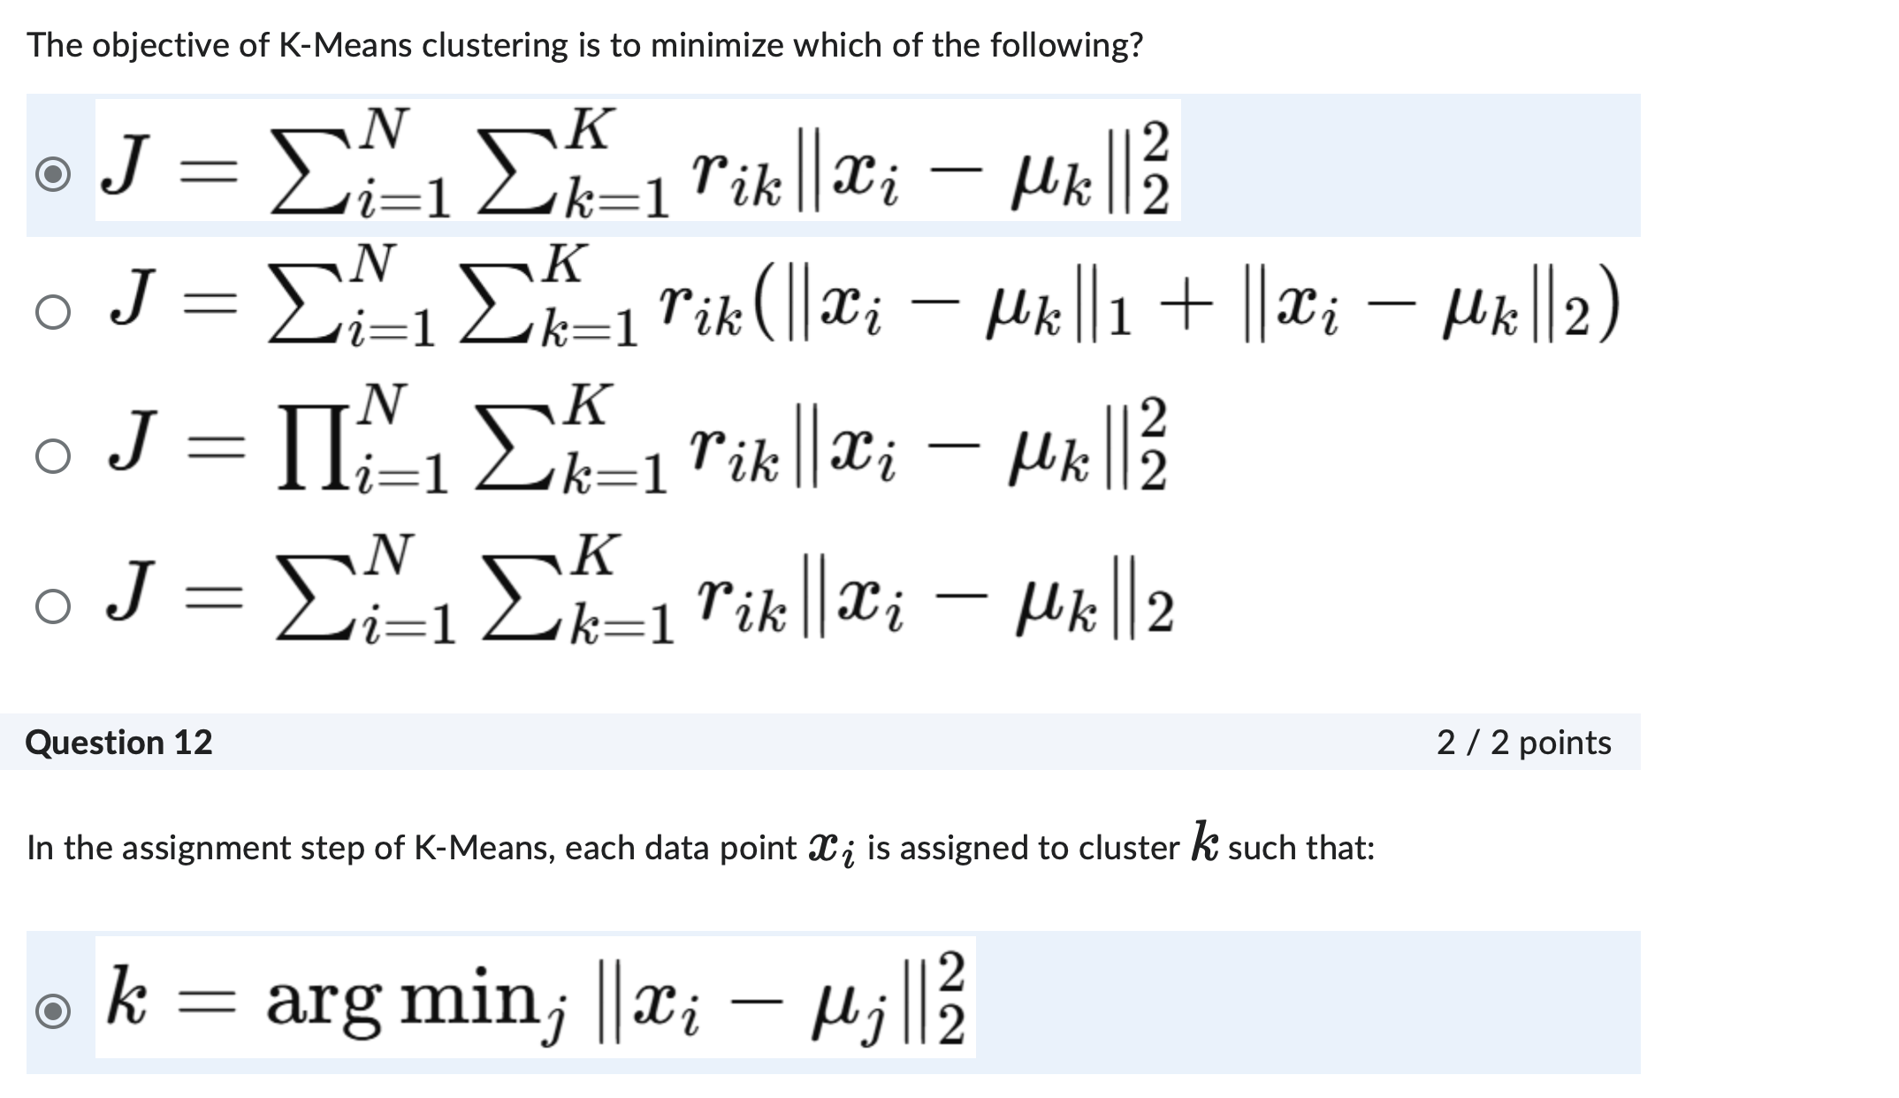
How can autoencoders be used for anomaly detection? Question options: Unselected By clustering data points based on their latent representations Selected By identifying data points that are poorly reconstructed by the autoencoder Unselected By using the autoencoder to generate synthetic data Unselected By training a classifier on the latent representations
Which of the following is a potential problem if you do not scale your data before applying PCA? Question options: Selected Features with large variance will dominate the principal components, skewing the results
SVD – PCA (method
In an autoencoder, if the input layer has 50 neurons and the bottleneck layer has 5 neurons, what is the compression ratio of the autoencoder? Question options: Unselected 5 Unselected 0.1 Unselected 50 Selected 10
How is an autoencoder trained? Question options: Unselected By minimizing the classification error Unselected By maximizing the difference between the input and the output Unselected By maximizing the classification accuracy Selected By minimizing the difference between the input and the output
What is the purpose of the decoder in an autoencoder? Question options: Unselected To add noise to the input data Selected To reconstruct the input data from the compressed representation Unselected To normalize the input data Unselected To compress the input data into a lower-dimensional representation
What is TRUE about Decision Trees in ML? Choose ALL that apply. Question options: Selected A Random Forest can be viewed as a collection of Decision Trees Selected The purpose of pruning in decision trees is to reduce the size of the tree and prevent overfitting
Which of the following is the key difference between bagging and boosting? Question options: Selected Bagging is an ensemble learning technique that creates multiple models from different subsets of the training data Unselected Boosting is always more effective than bagging Unselected Bagging is used for classification tasks, while boosting is used for regression tasks Selected Bagging focuses on reducing variance, while boosting focuses on reducing bias

